Chapter 16 programming

**16.2:** 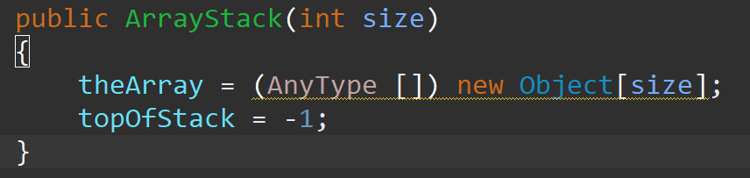

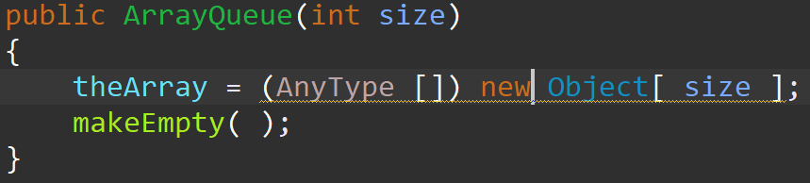

**16.3:** bigOh time is constant and makes sense for both array and list push and pop methods

